長庚大學資訊工程學系一百零九學年度上學期計算機圖學課程小考試題
上課班級: 三年甲班 授課老師: 林俊淵
受測範圍: Slides 1~6

- Please write an OpenGL program to draw the picture. (Total:60 points)
- 30 points  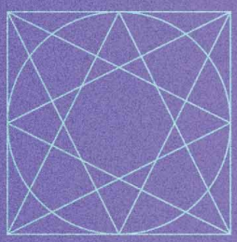 | - 40 points (相似就可以)(背景不用, 但相關圖案都有要, 只是可以類似就好)
  

- Step 1: Please write a OpenGL program to show the Figure 2(a). 10 points.
Step 2: Please change the Ortho2D to show the Figure 2(b). 10 points.
Step 3: Please change the Ortho2D to show the Figure 2(c). 10 points.
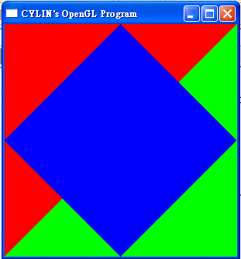  (a) | 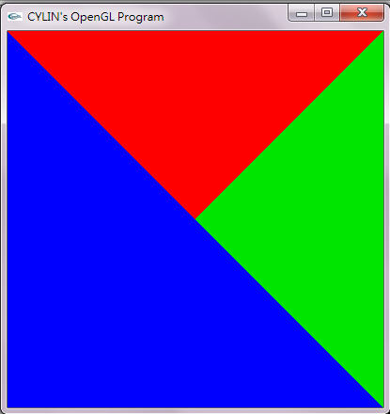  (b) | 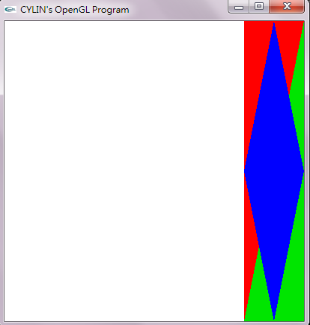  (c)

完成全部作答後, 需要繳交以下檔案:
- .c or .cpp 檔案. (請標名1(a), 1(b), 2(a), 2(b), 2(c))
- .exe檔案. (Mac不用)(請標名1(a), 1(b), 2(a), 2(b), 2(c))
- 跑出來的圖形( .jpg) (請標名1(a), 1(b), 2(a), 2(b), 2(c))

請記得儲存檔案，請將全部檔案壓縮成【學號.rar】然後上傳到ftp上.

